Name ______________________ Group # ________

Quiz Series RLC
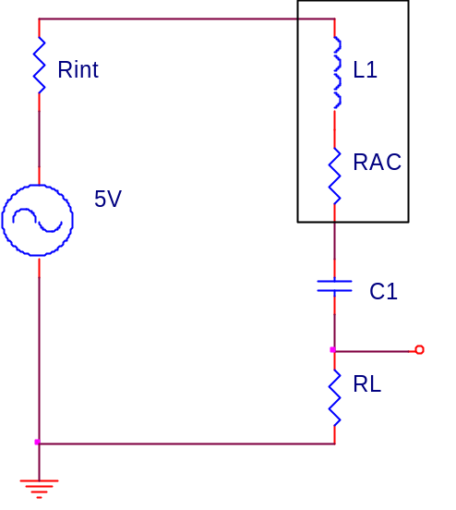
L₁ = | 80mH
RAC = | 121Ω
C₁ = | .01uf
R_{int} = | 100Ω
R_{L} = | 700Ω

f_{R} = |  | f_{co1} = |  | f_{co2} =

@Resonance |  | @f_{co1} |  | @f_{co2}
Q, Coil = |  | X_{L} = |  | X_{L} =
Q, Circuit = |  | X_{C} = |  | X_{C} =
R_{Total} = |  | I_{T} = |  | I_{T} =
X_{L} = |  | E_{L} = |  | E_{L} =
X_{C} = |  | E_{C} = |  | E_{C} =
I_{T} =
E_{Load} =
Z =
BW =

